**Introduction:**

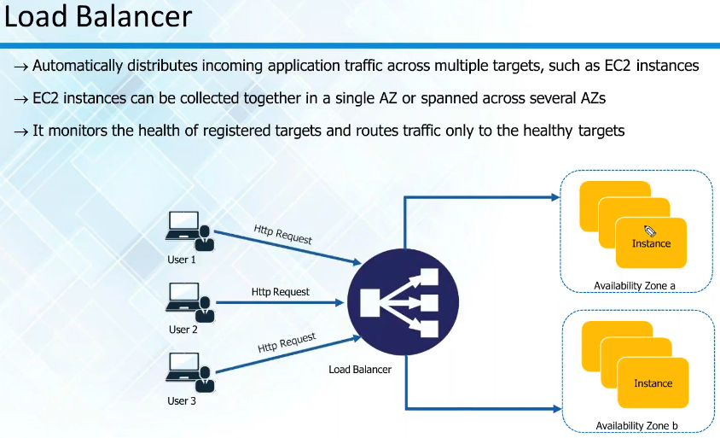

* All the requests hit load balancer first and then the load balancer will route the traffic to the healthy server
* If all the servers are healthy. It follows round robin scenario
* **Example,** we have 6 servers, then the 1st request goes to 1st server, 2nd request goes to 2nd server etc. and then 7th request comes to 1st server. This is called the round robin scenario
* This is the default behaviour of load balancer

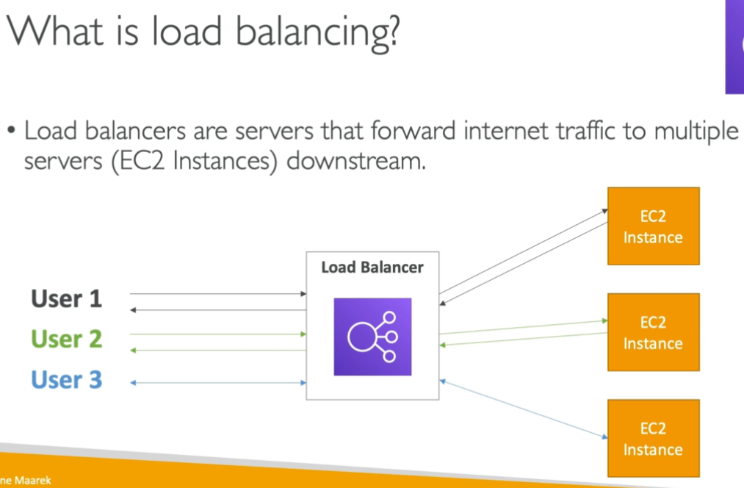

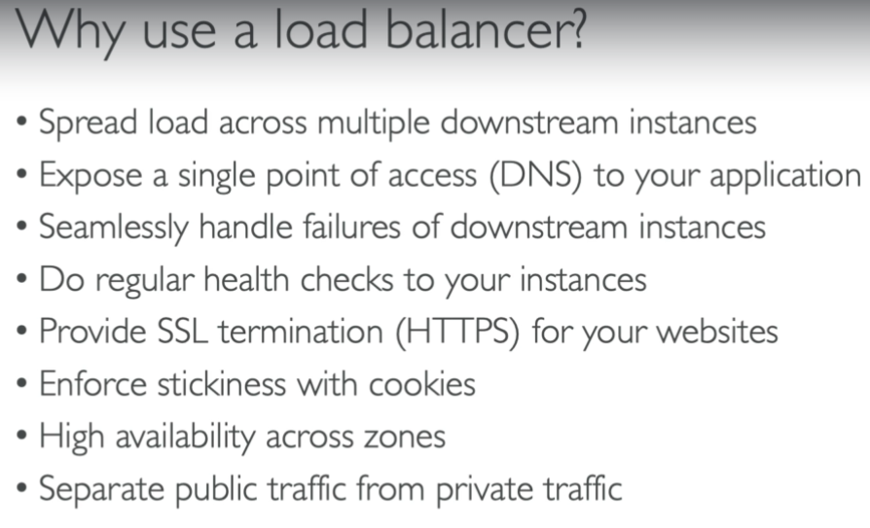

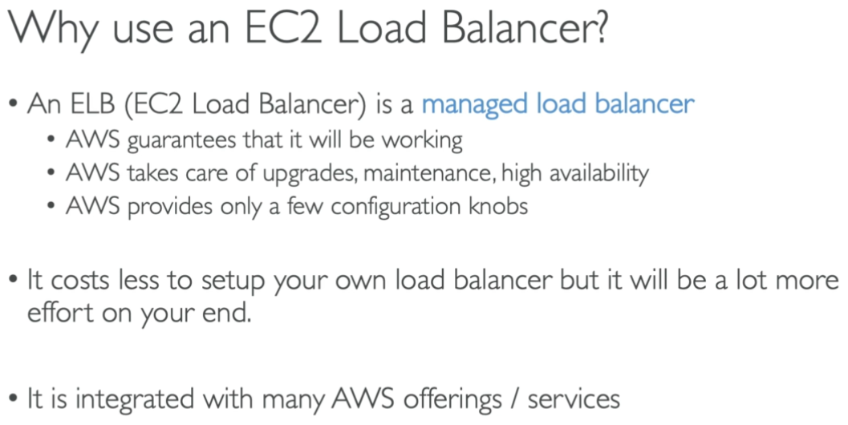

**Health checks:**

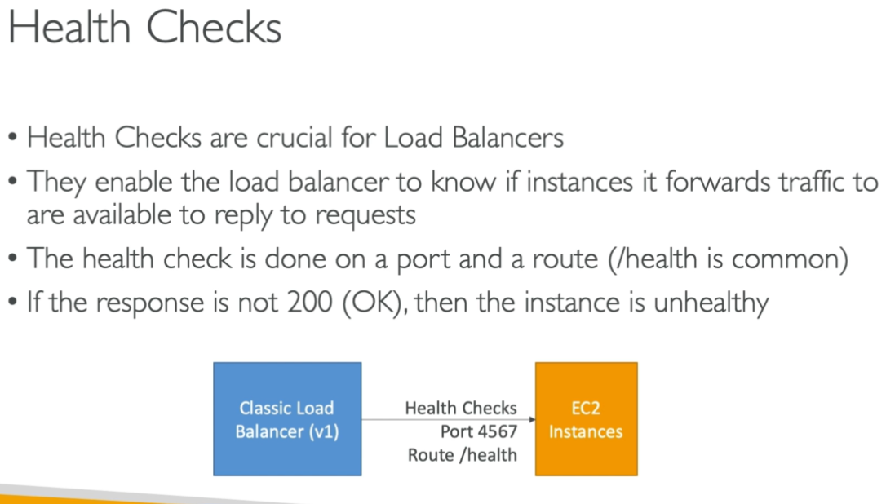

**Types of load balancers:**

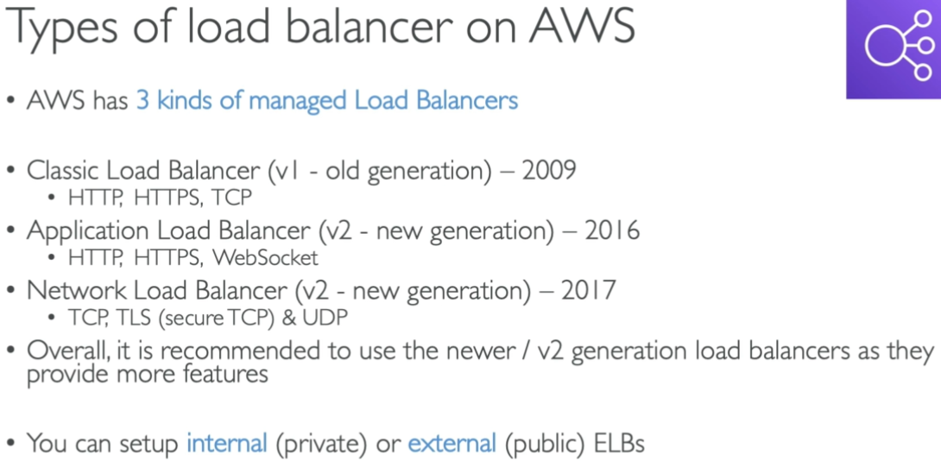

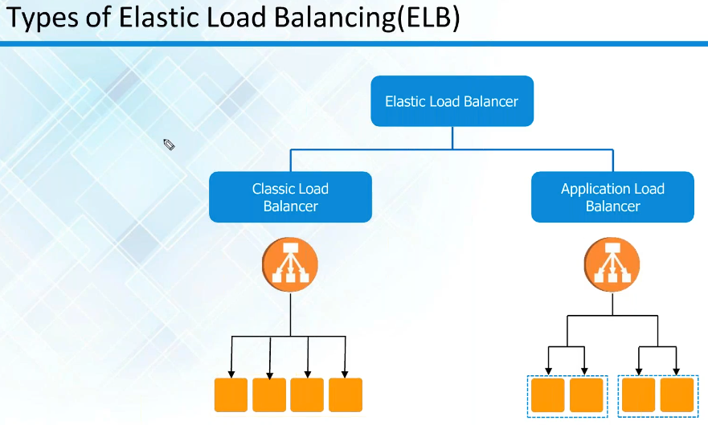

* Classic load balancer is old whereas application and network load balancers are new
* Application load balancer with web application on http, https traffic
* And network load balancer can handle TCP protocol whereas classic load balancer supports both

**Security groups in load balancers:**

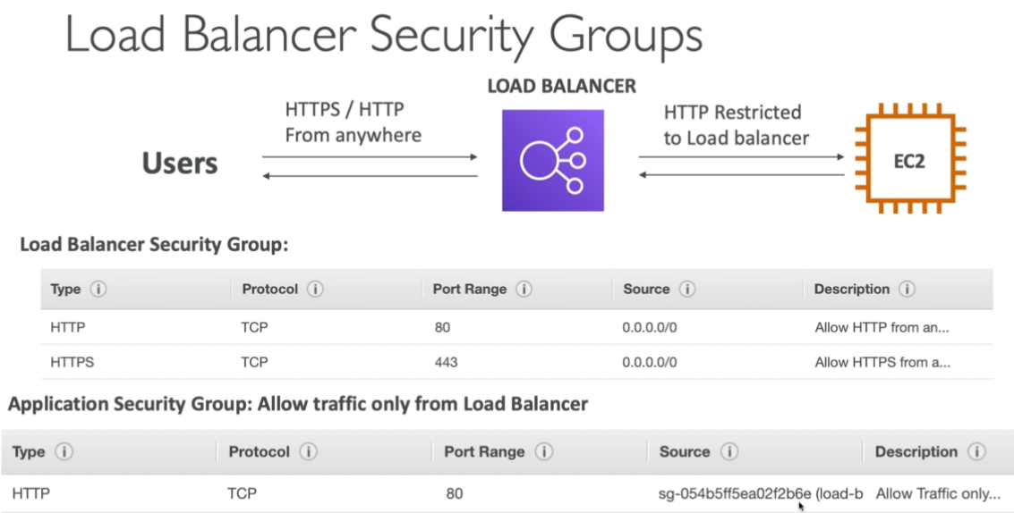

* The load balancer will have a security group with HTTP or HTTPS
* EC2 instance will have a security group enabling the access from load balancer’s security group as above.

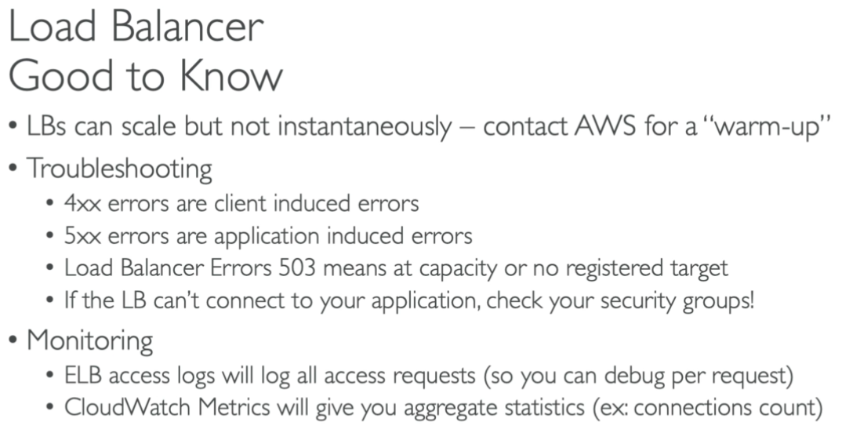

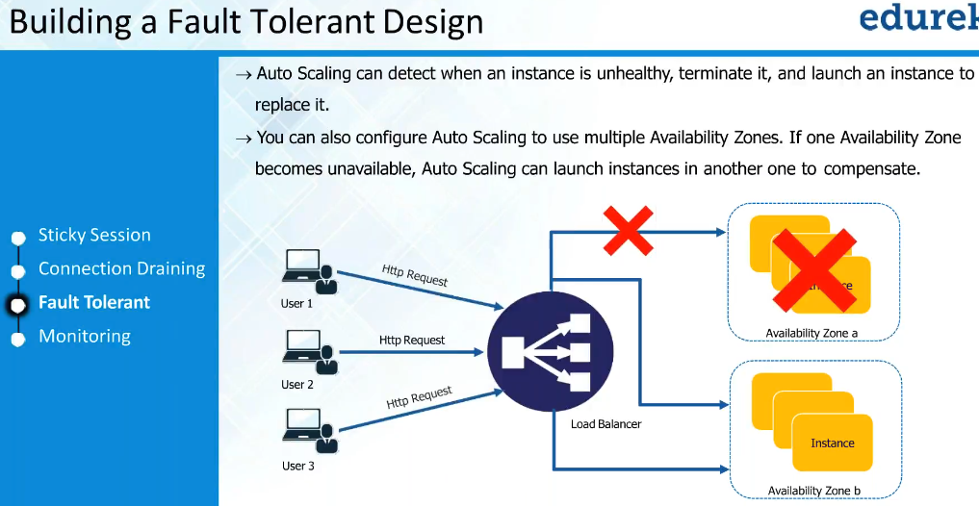

* Load balancer also has inbuilt fault tolerant. It can detect the unhealthy servers and won’t send traffic to that server. If the entire availability zone is unhealthy. Then it won’t send the traffic to that zone. It will mark as unhealthy

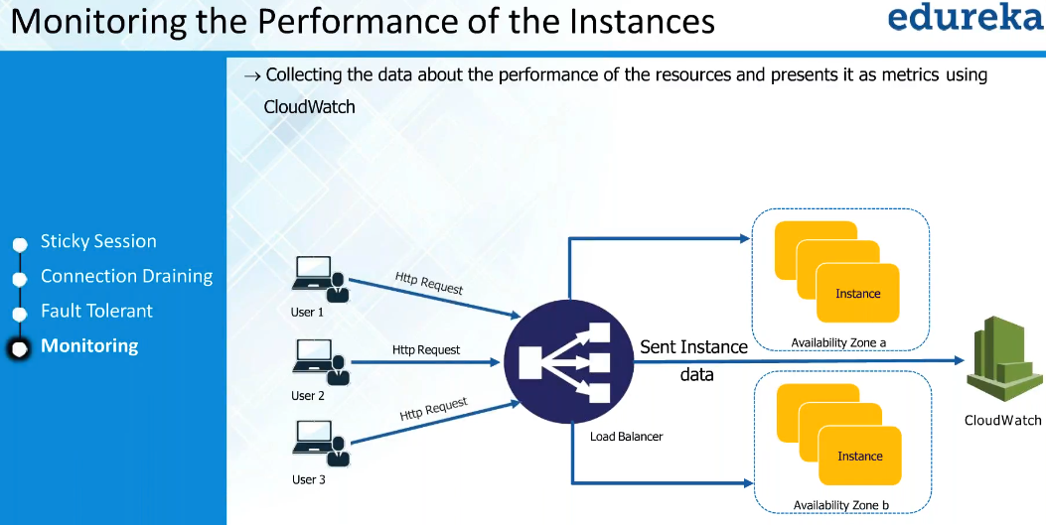

* Load balancer can also perform monitoring, it can check how the instances are performing etc and push the info to CloudWatch